|  |  |  |
| --- | --- | --- |
| **Vulnerability** | **Exploit/Problem** | **Mitigation** |
| All users’ passwords are stored as plain text. | Open the database with   * **Sqlite3 Database.db**   Run SQL Command   * SELECT * * FROM users   To view entire table of plaintext passwords.1 | Add a salt to the plaintext password and then hash the result. |
| Multiple ports have been left open. | Port 8888 can be used to get a remote shell with root privileges. |  |
|  |  |  |
|  |  |  |
|  |  |  |
|  |  |  |
|  |  |  |

# Screenshots

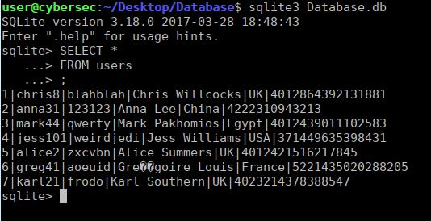

1